**Chapter 1**

**Introduction**

* 1. **Overview Of The System**

Flow measurement is the quantification of bulk fluid movement. Flow meters are, as the name suggests, devices that measure flow in a piped system. Depending on the application, flowrate is measured as either volume or mass. This system can clamp onto a pipe and measure flow with a type of sensor placed inside the pipe or act as an all-in-one component, allowing fluid to pass through their bodies as it measure. There are manifold applications of this digital flowmeter.

In this project we are focusing on design of digital flow meter system which will give a digital output. This flow meter can be constructed using low cost system. This Flow Meter is used to provide accurate monitoring and/or flow control. Industrial applications require precise calculation of quantity, that’s why our main objective is to come up with cost effective digital flow meter.

Hall Effect water flow sensor is used as a sensing unit with a turbine rotor inside it whose speed of rotation changes with the different rate of flow of water. The Hall Effect sensor outputs the corresponding pulse train for frequency input to the microcontroller. The whole system comprises of Atmega328P microcontroller, G1/2 Hall Effect water flow sensor, a water pump, 5V supply, OLED and some passive components.

* 1. **Problem Statement**

Industrial applications require precise calculation of quantity, many flow meter are available like mechanical or in analog format which have less accuracy and high maintenance. So we have to come up with compact, more accurate, and digital water flow meter.

**1.3 Objectives**

* The main objective of this project is to create a cost efficient digital flow meter.
* To support Digital India concept by digitalizing our flow meter sensor.
* To provide accurate and precise digital flow meter.

**Chapter 2**

**Literature Survey**

**2.1 Literature**

We have studied many previous works done in this field by different researchers. Lot of research work has been carried out for evolving different water flow measurement techniques.

[1]. Luis Castalieret. al (1997) describes design and fabrication of a low cost water flow meter which can measure up to 9 liter/minute, avoiding direct contact of flow with silicon sensors in Techniques of measuring water flow rates with the help of neural networks had also been proposed.

[2]. ShiqianCai and HalukToral (1993) proposed a technique of measuring flow rate in Air-Water Horizontal Pipeline with the help of Neural Networks. In this paper the Kohonenselforganising Feature map (KSOFM) and the multi-layer back propagation network (MBPN) were applied in a hybrid network model to measure the flow rate of individual phases in horizontal air water flow.

[2]. Santhosh KV and BK Roy (2012) proposed an intelligent flow measurement technique using Ultrasonic Flow Meter with optimized neural network. The objective of this work includes: to extend the linearity range of measurement to 100% of the input range, to make the measurement system adaptive to variations in pipe diameter, liquid density, and liquid temperature, and to achieve the above two objectives by an optimal Artificial Neural Network

[3]*.* Young-Woo Lee et. al (2008) had developed a wireless Digital Water Meter with Low PowerConsumption for Automatic Meter Reading in which they used magnetic hole sensors to calculate the amount of water consumption and they had used ZigBee wireless protocol to transfer amount of water consumption to the gateway

[4]*.* JavadRezanejadGatabiet. al (2010) developed an auxiliary fluid flow meter in which the flow of an auxiliary fluid is measured, instead of direct measurement of the main fluid flow. The auxiliary fluids injected into the main fluid and with measuring its travel time between two different positions, its velocity could be calculated.

[5]. Zhang Wenzhaoet. al (2010) had developed a liquid differential pressure flow sensor for Straight Pipe. In this system a pressure difference between the upstream branch pipe and the downstream pipe is detected and converted into a voltage signal by the DP sensor. This voltage signal is transmitted to a microprocessor to determine liquid flow rate.

**2.2MarketSurvey:**

**2.2.1 Mechanical Flowmeter**

### Product Description

Flowtech Measuring Instruments Pvt Ltd, producer of oval gear flow meter with **Mechanical Fuel Flow Meter**Digital display battery operated, Flow sensor with pulse output/4 to 20 mA output Flowtech is producer of CE certified mechanical oval gear fuel flow meter for measuring flow of fuel, kerosene, Gasoline, diesel, light oil, heavy oil, petrol ,LDO, HDO, wine, bear, alcohol,milk, juice, coffee, tea, all chemical and pharmaceutical drug.

**Application**:

* Diesel Flow meter is a kind of positive displacement Meter to measure the liquid flow or instantaneous flow of the Pipe tube. lt is a kind of accumulate meter. With Characteristics of high accuracy, small change by the fluid Viscosity, it is widely used to measure oil kind liquid, forbidden to measure corrosive.

**Working Principle:**

* The measurement part of oval gear flow meter is posed by two elliptical gears mesh with each other and its shell (measuring room). or has no rotating torque even it effected the liquid pressure, but the above gears will move by the rotating Pressure .ln the status of the above gears driving gear, and the bottom gear is driven gear. both of these two gears have rotating torque by the liquid pressu/'e, and they move with the direction of the arrow to space The gear space is opposite to, The figure shows that the flow meter works by two elliptical gears to mesh with each other, its working process are as follows: P1 in the figure shows the pressure of liquid from inlet side, to show the outlet pressure, the bottom rot the bottom gear is driving gear, and above gear is driven gear. The bottom gear pushes the liquid out from the half moon space under the liquid press pushes liquid volume four times of "measurement room". So, as long as the rotation of gears, the liquid volume can be counted.
* The measurement part of oval gear flow meter is posed by two elliptical gears mesh with each other and its shell (measuring room). or has no rotating torque even it effected the liquid pressure, but the above gears will move by the rotating Pressure .ln the status of the above gears driving gear, and the bottom gear is driven gear. both of these two gears have rotating torque by the liquid pressu/'e, and they move with the direction of the arrow to space The gear space is opposite to, The figure shows that the flow meter works by two elliptical gears to mesh with each other, its working process are as follows: P1 in the figure shows the pressure of liquid from inlet side, to show the outlet pressure, the bottom rot the bottom gear is driving gear, and above gear is driven gear. The bottom gear pushes the liquid out from the half moon space under the liquid press pushes liquid volume four times of "measurement room". So, as long as the rotation of gears, the liquid volume can be counted.

### Additional Information

|  |  |
| --- | --- |
| Item Code | FFM-063 |
| Delivery Time | 2 Weeks |
| Port Of Dispatch | Vadodara |
| Production Capacity | 500 piece per Month |
| Packaging Details | wooden cages |
| Payment Terms | L/C (Letter of Credit)/T/T (Bank Transfer) |

### Product Image

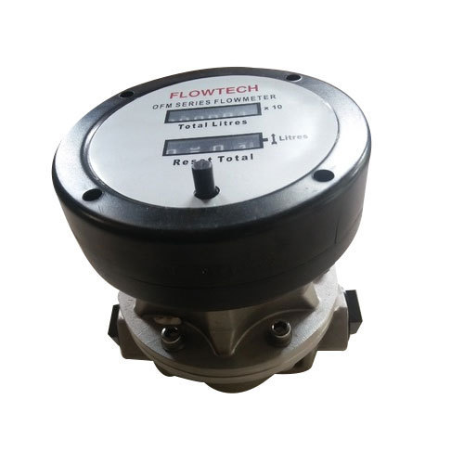

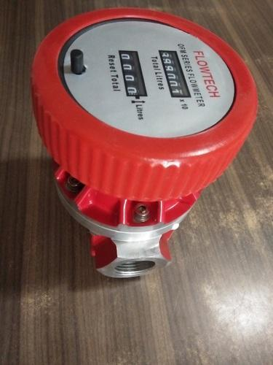

**Fig 2.1** Mechanical flowmeter

**2.2.2 Electromagnetic Flowmeter**

**Electromagnetic meters** can handle most liquids and slurries, providing that the material being metered is electrically conductive. Major components are the flow tube (primary element). The flow tube mounts directly in the pipe. Pressure drop across the meter is the same as it is through an equivalent length of pipe because there are no moving parts or obstructions to the flow. The voltmeter can be attached directly to the flow tube or can be mounted remotely and connected to it by a shielded cable.

Electromagnetic flowmeters operate on Faraday's law of electromagnetic induction that states that a voltage will be induced when a conductor moves through a magnetic field. The liquid serves as the conductor; the magnetic field is created by energized coils outside the flow tube. The amount of voltage produced is directly proportional to the flow rate. Two electrodes mounted in the pipe wall detect the voltage, which is measured by the secondary element.

Electromagnetic flowmeters have major advantages: They can measure difficult and corrosive liquids and slurries; and they can measure forward as well as reverse flow with equal accuracy. Disadvantages of earlier designs were high power consumption, and the need to obtain a full pipe and no flow to initially set the meter to zero. Recent improvements have eliminated these problems. Pulse-type excitation techniques have reduced power consumption, because excitation occurs only half the time in the unit. Zero settings are no longer required.

|  |
| --- |
|  |

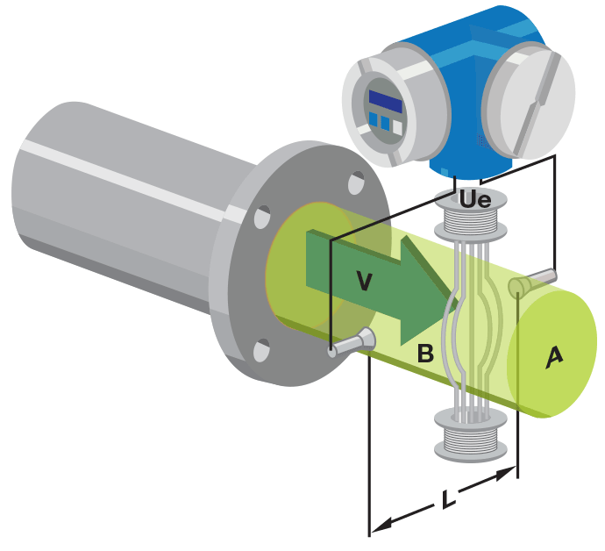

Fig 2.2Electromagnetic Flowmeter

**Chapter 3**

**System Design**

**_____________________________________________________________**

**3.1 Block Diagram**

Power Supply

Filter

&

Pump

Display

Flow Meter

Water Tank

Control Panel

**Fig. 3.1** Block Diagram

**3.2 System Specifications:**

**3.2.1Power Supply**

A power supply is an electronic device that supplies electric energy to a load. The primary function of a power supply is to convert one form of electrical energy into other and as a result power supply are sometimes referred to as electric power converters. Some power supplies are discrete, stand-alone devices, whereas others are built into larger devices along with their loads. The types also include fixed, variable and dual power supply.

**3.2.2 Microcontroller**

The Atmega328P is a low-power, high-performance CMOS 8-bit microcomputer with 4 Kbytes of Flash Programmable and Erasable Read Only Memory (PEROM). The device is manufactured using Atmel’s high density non-volatile memory technology and is compatible with the industry standard MCS-51 instruction set and pinout.

The on-chip Flash allows the program memory to be reprogrammed in-system or by a conventional non-volatile memory programmer. By combining a versatile 8-bit CPU with Flash on a monolithic chip, the Atmel AT89C51 is a powerful microcomputer which provides a highly flexible and cost effective solution to many embedded control applications.

  The AT89C51 provides the following standard features: 4Kbytes of Flash, 128 bytes of RAM, 32 I/O lines, two 16-bit timer/counters, a five vector two-level interrupt architecture, a full duplex serial port, on-chip oscillator and clock circuitry. In addition, the AT89C51 is designed with staticlogic for operation down to zero frequency and supports two software selectable power saving modes. The Idle Mode stops the CPU while allowing the RAM, timer/counters,

**Features:**

➢     Compatible with MCS-51 Products

➢     4 Kbytes of In-System Reprogrammable Flash Memory. Endurance   1,000 Write/Erase Cycles

➢     Fully Static Operation: 0 Hz to 24 MHz

➢     Three-Level Program Memory Lock

➢     128 x 8-Bit Internal RAM

➢     32 Programmable I/O Lines

➢     Two 16-Bit Timer/Counters

➢     Six Interrupt Sources

➢     Programmable Serial Channel

➢     Low Power Idle and Power Down Modes

**3.2.3Sensor**

Flow meter basically works with the output of the flow sensor. In this system in order to calculate the flow the rotor surrounded by a magnet along with the Hall Effect sensor is used. This is known as G1/2 water flow sensor. As the water flows through the rotor, its blades rotates. As the turbine rotates magnetic field is produced and accordingly an Ac pulse is generated which is then converted into the digital output with the help of Hall Effect sensor placed just after the turbine. The number of pulses generated per liter can be counted by the software programming. Thus pulses produce an output frequency which is directly proportional to the volumetric flow rate/total flow rate through the meter. Also measuring flow rate through rotating rotor provides high accuracy, excellent repeatability, simple structure and low pressure loss Project Work Scope.



|  |  |
| --- | --- |
| Parameter of the sensor | Value / Range |
| Working Voltage (Volts) | 5 - 24 |
| Maximum Current (mA) | 15 |
| Flow rate range (L/min) | 1 – 30 |
| Operating temperature (ºC) | 0 – 80 |
| Liquid temperature (ºC) | <120 |
| Operating humid ity (RH) | 35%-90% |
| Operating pressure (Mpa) | Under 1.2 |
| Store temperature (ºC) | -25 to +80 |

**3.2.4Relay**

**Relays** are switches that open and close circuits electromechanically or electronically. **Relays** control one electrical circuit by opening and closing contacts in another circuit. As **relay** diagrams show, when a **relay** contact is normally open (NO), there is an open contact when the **relay** is not energized.

**3.2.5 C language**

C is a high-level and general-purpose programming language that is ideal for developing firmware or portable applications. C belongs to the structured, procedural paradigms of languages. It is proven, flexible and powerful and may be used for a variety of different applications. Although high level, C and assembly language share many of the same attributes.

**3.2.6LED**

A light-emitting diode (LED) is a two-[lead](https://en.wikipedia.org/wiki/Lead_(electronics))[semiconductor](https://en.wikipedia.org/wiki/Semiconductor)[light source](https://en.wikipedia.org/wiki/Light_source). It is a [p–n junction](https://en.wikipedia.org/wiki/P%E2%80%93n_junction)[diode](https://en.wikipedia.org/wiki/Diode) that emits light when activated. When a suitable [current](https://en.wikipedia.org/wiki/Electric_current) is applied to the leads,[electrons](https://en.wikipedia.org/wiki/Electron) are able to recombine with [electron holes](https://en.wikipedia.org/wiki/Electron_hole) within the device, releasing energy in the form of [photons](https://en.wikipedia.org/wiki/Photon). This effect is called [electroluminescence](https://en.wikipedia.org/wiki/Electroluminescence), and the color of the light (corresponding to the energy of the photon) is determined by the energy [band gap](https://en.wikipedia.org/wiki/Band_gap) of the semiconductor. LEDs are typically small (less than 1 mm2) and integrated optical components may be used to shape the [radiation pattern](https://en.wikipedia.org/wiki/Radiation_pattern).

**3.3 Component Selection**

**3.3.1 Battery**

The nine-volt battery, or 9-volt battery, is a common size of battery that was introduced for the early [transistor radios](https://en.wikipedia.org/wiki/Transistor_radio). It has a rectangular prism shape with rounded edges and a polarized snap connector at the top. This type is commonly used in [walkie-talkies](https://en.wikipedia.org/wiki/Walkie-talkie), [clocks](https://en.wikipedia.org/wiki/Clock) and [smoke detectors](https://en.wikipedia.org/wiki/Smoke_detector).

The nine-volt battery format is commonly available in primary carbon-zinc and alkaline chemistry, in primary lithium iron disulfide, and in rechargeable form in nickel-cadmium, nickel-metal hydride and lithium-ion. Mercury-oxide batteries of this format, once common, have not been manufactured in many years due to their mercury content. [Designations](https://en.wikipedia.org/wiki/Battery_nomenclature) for this format include *NEDA 1604* and *IEC 6F22* (for zinc-carbon) or *MN1604 6LR61* (for alkaline). The size, regardless of chemistry, is commonly designated PP3—a designation originally reserved solely for carbon-zinc, or in some countries, *E* or *E-block*.[[1]](https://en.wikipedia.org/wiki/Nine-volt_battery#cite_note-1)

Most nine-volt alkaline batteries are constructed of six individual 1.5 V LR61 cells enclosed in a wrapper.[[2]](https://en.wikipedia.org/wiki/Nine-volt_battery#cite_note-IEC_60086-2-2011_§7.6.1.12-2) These cells are slightly smaller than LR8D425 [AAAA cells](https://en.wikipedia.org/wiki/AAAA_battery) and can be used in their place for some devices, even though they are 3.5 mm shorter. Carbon-zinc types are made with six flat cells in a stack, enclosed in a moisture-resistant wrapper to prevent drying. Primary lithium types are made with three cells in series.[[3]](https://en.wikipedia.org/wiki/Nine-volt_battery#cite_note-3)

**3.3.2Water Pump**

A pump is a device that moves fluids ([liquids](https://en.wikipedia.org/wiki/Liquid) or [gases](https://en.wikipedia.org/wiki/Gas)), or sometimes [slurries](https://en.wikipedia.org/wiki/Slurry), by mechanical action. Pumps can be classified into three major groups according to the method they use to move the fluid: *direct lift*, *displacement*, and *gravity* pumps.Pumps operate by some mechanism (typically [reciprocating](https://en.wikipedia.org/wiki/Reciprocating_motion) or [rotary](https://en.wikipedia.org/wiki/Rotation)), and consume [energy](https://en.wikipedia.org/wiki/Energy) to perform [mechanical work](https://en.wikipedia.org/wiki/Mechanical_work) moving the fluid. Pumps operate via many energy sources, including manual operation, [electricity](https://en.wikipedia.org/wiki/Electricity), [engines](https://en.wikipedia.org/wiki/Engines), or [wind power](https://en.wikipedia.org/wiki/Wind_power), come in many sizes, from microscopic for use in medical applications to large industrial pumps. Mechanical pumps serve in a wide range of applications such as [pumping water from wells](https://en.wikipedia.org/wiki/Water_well_pump), [aquarium filtering](https://en.wikipedia.org/wiki/Aquarium_filter), [pond](https://en.wikipedia.org/wiki/Pond) filtering and [aeration](https://en.wikipedia.org/wiki/Water_aeration), in the [car industry](https://en.wikipedia.org/wiki/Car_industry) for [water-cooling](https://en.wikipedia.org/wiki/Water_cooling) and [fuel injection](https://en.wikipedia.org/wiki/Fuel_injection), in the [energy industry](https://en.wikipedia.org/wiki/Energy_industry) for [pumping oil](https://en.wikipedia.org/wiki/Pumping_(oil_well)) and [natural gas](https://en.wikipedia.org/wiki/Natural_gas) or for operating [cooling towers](https://en.wikipedia.org/wiki/Cooling_tower). In the [medical industry](https://en.wikipedia.org/wiki/Medical_industry), pumps are used for biochemical processes in developing and manufacturing medicine, and as artificial replacements for body parts, in particular the [artificial heart](https://en.wikipedia.org/wiki/Artificial_heart) and [penile prosthesis](https://en.wikipedia.org/wiki/Penile_prosthesis).

**3.3.3 Rotary ( Pelton) Wheel**

The [Pelton wheel](https://en.wikipedia.org/wiki/Pelton_wheel) turbine (better described as a [radial turbine](https://en.wikipedia.org/wiki/Radial_turbine)) translates the mechanical action of the Pelton wheel rotating in the liquid flow around an axis into a user-readable rate of flow (gpm, lpm, etc.). The Pelton wheel tends to have all the flow traveling around it with the inlet flow focused on the blades by a jet. The original Pelton wheels were used for the [generation of power](https://en.wikipedia.org/wiki/Electricity_generation) and consisted of a radial flow turbine with "reaction cups" which not only move with the force of the water on the face but return the flow in opposite direction using this change of fluid direction to further increase the [efficiency](https://en.wikipedia.org/wiki/Energy_conversion_efficiency) of the [turbine](https://en.wikipedia.org/wiki/Turbine).

**3.3.4 Sevan Segment Display**

[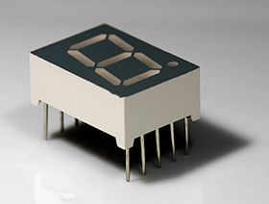](https://en.wikipedia.org/wiki/File:Seven_segment_02_Pengo.jpg)

A typical 7-segment LED

A seven-segment display (SSD), or seven-segment indicator, is a form of electronic [display device](https://en.wikipedia.org/wiki/Display_device) for displaying [decimal](https://en.wikipedia.org/wiki/Decimal)[numerals](https://en.wikipedia.org/wiki/Numeral_system) that is an alternative to the more complex [dot matrix displays](https://en.wikipedia.org/wiki/Dot_matrix_display). Seven-segment displays are widely used in [digital clocks](https://en.wikipedia.org/wiki/Digital_clock), electronic meters, basic calculators, and other electronic devices that display numerical information.

**3.3.57 Segment Display Pin Configuration**

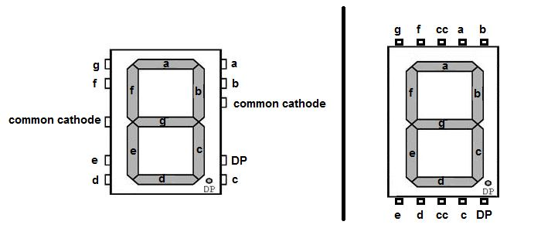

**3.3.67-Segment Display Features:**

* Available in two modes Common Cathode (CC) and Common Anode (CA)
* Available in many different sizes like 9.14mm,14.20mm,20.40mm,38.10mm,57.0mm and 100mm (Commonly used/available size is 14.20mm)
* Available colours: White, Blue, Red, Yellow and Green (Res is commonly used)
* Low current operation
* Better, brighter and larger display than conventional LCD displays.
* Current consumption : 30mA / segment
* Peak current : 70mA

**3.5Working:**

Here Pump will be on when we set some amount of value from control panel, the filter attached to the pump which filters the water and give it to the flow meter. Flow meter then count the amount of water flown from the pipe and generates the pulse. These pulse then converted into the electrical equivalent voltage and display on the LCD board. When the set amount of water is flown from the flow meter then the Pump will be turn off automatically with the help of relay circuit.

Due to the digital flow meter we can count the amount of water flow through the pipe more precisely. By using this digital flow meter we can control the access amount of water use which reduces the extra or unnecessary water use.

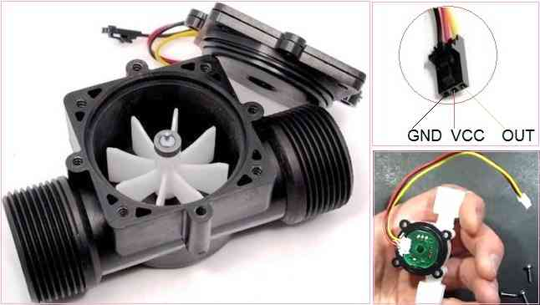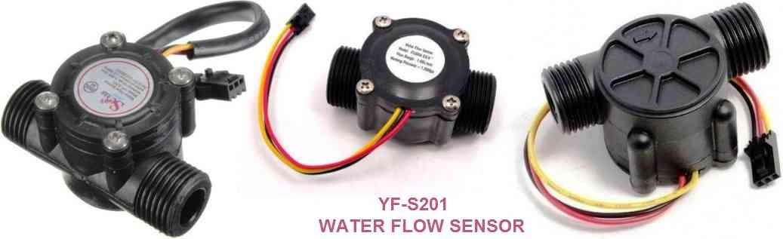

**3.7Algorithm**

The various algorithms/methods related to flow measurements are:

Flow Rate and Consumption Measurement and Monitoring Technique For the purposes of analysis of the obtained data from readout circuit to calculate and display the water flow rate and consumption, a processing and monitoring algorithm is required to develop on a standalone system. Basically, the angular speed is considered as one of the most important types of measurement in rotary based machines in order to monitor and control the effective factors on rotation. Basically, there are several techniques to measure the speed of a rotating shaft.

The applied speed measurement approach depends on the

1. sensory system and
2. interface circuit architecture

Although, the angular velocity can be measured by different methods which are classified into two main categories;

1)timer /counter based and

2) analog-to-digital based techniques.

These two techniques can also be divided to variety types based on the predetermined parameters of measurement technique and the data acquisition approach. The most appropriate technique is selected according to the required range of measurement such as maximum and minimum value of speed, the required accuracy, and the output signal of interface circuit.

**3.8 Flowchart**

Water pump starts and flow meter start

Senses the flow and measure pulses

Converts the pulses in digital using signal conditioning

display

Turn off the system

**Chapter 4**

**Costing**

|  |  |  |
| --- | --- | --- |
| **Serial No** | **Component** | **Cost** |
|  | Microcontrller (89c51) | 100/- |
|  | Hall Effect Sensor | 70/- |
|  | Magnetic coil | 100/- |
|  | Rotary wheel | 60/- |
|  | **TOTAL COST** | 330/- |

**Table 4.1**Budget Approximations

|  |  |  |  |  |  |  |  |
| --- | --- | --- | --- | --- | --- | --- | --- |
| **Bill of material (Digital Water Flow Meter)** | | | | | | | |
|  | | | | | | | |
|
| **SR. NO** | **Name of component** | **Designator** | **Footprint** | **Quantity** | **Manufacturer Part** | **Manufacturer** | **Price (Inclusive of Taxes)** |
| 1 | 1117 3.3 | U1 | 1117-SOT89 | 1 | LM1117 |  | Rs.9.50 |
| 2 | ATMEGA328P-AU | U2 | TQFP-32_7X7X08P | 1 | ATMEGA328P-AU | MICROCHIP | Rs.230.00 |
| 3 | 4pin I2C monochrome OLED Display | OLED1 | OLED 1.3 IIC/I2C | 1 |  |  | Rs. 292.00 |
| 4 | 1206 SMD Resistor 1% 10K ohm | R1,R2,R4,R5 | 1206 | 4 | 1206 SMD Resistor 1% 10K ohm |  | Rs.18.00 |
| 5 | 1u Capacitor | C1 | CAP-D3.0XF1.5 | 1 |  |  | Rs.20.00 |
| 6 | 1k Resistor | R3 | AXIAL-0.3 | 1 |  |  | Rs.20.00 |
| 7 | LED-3MM | LED1 | LED-3MM/2.54 | 1 | 204-10SURD/S530-A3 | EVERLIGHT | Rs.19.00 |
| 8 | 16MHz | X1 | OSC-49S-1 | 1 | X49SD12MSD2SC | YXC | Rs. 13.00 |
| 9 | 22pF Capacitor | C2,C3 | RAD-0.1 | 2 |  |  | Rs. 20.00 |
| 10 | Header-Female-2.54_1x5 | H1 | HDR-5X1/2.54 | 1 | 2.54mm 1*5p Female header | BOOMELE | RS.59.00 |
| 11 | EVQ22705R | RESET | KEY-6.0*6.0-4 | 1 | EVQ22705R | PANASONIC | Rs. 10.00 |
| 12 | Header-Male-2.54_1x3 | P1 | HDR-3X1/2.54 | 1 | Header2.54mm 1*3P | BOOMELE | Rs. 49.00 |

**Chapter 5**

**Further Work**

**_____________________________________________________________**

* To develop adigital flow meter that automatically control flow of liquid.
* To develop flow processing analysis system to be later used in feature extraction.
* To develop a testing system that proceeds to command if the condition.
* To interface microcontroller hardware and software on a laptop computer.
* We can store the data for future uSE

**Chapter 6**

**Conclusion**

**_____________________________________________________________**

The idea is to build a digital flowmeter which can be controlled using microcontroller. Compact size of sensors, more reliability, Accuracy is an added advantage to this technique. Using this technique it is possible to control & measure the flow of liquid in the pipe. In summary, this technique can replace magnetic and electro-magnetic flow meters types in an economical way.

**Compact size of sensors:**

**Reliability:**

**Accuracy:**

**Chapter 7**

**References**

[1]. Luis Castalieret. al (1997) describes design and fabrication of a low cost water flow meter which can measure up to 9 liter/minute, avoiding direct contact of flow with silicon sensors in Techniques of measuring water flow rates with the help of neural networks had also been proposed.

[2]. ShiqianCai and HalukToral (1993) proposed a technique of measuring flow rate in Air-Water Horizontal Pipeline with the help of Neural Networks.

[2]. Santhosh KV and BK Roy (2012) proposed an intelligent flow measurement technique using Ultrasonic Flow Meter with optimized neural network.

[3]*.* Young-Woo Lee et. al (2008) had developed a wireless Digital Water Meter with Low PowerConsumption for Automatic Meter Reading in which they used magnetic hole sensors to calculate the amount of water consumption and they had used ZigBee wireless protocol to transfer amount of water consumption to the gateway

[4]*.* JavadRezanejadGatabiet. al (2010) developed an auxiliary fluid flow meter in which the flow of an auxiliary fluid is measured, instead of direct measurement of the main fluid flow. The auxiliary fluids injected into the main fluid and with measuring its travel time between two different positions, its velocity could be calculated.

[5]. Zhang Wenzhaoet. al (2010) had developed a liquid differential pressure flow sensor for Straight Pipe.

**Conclusions**

With all the accumulated effort invested in Ametist, there are reasons to believe that at the end of the project timed automata technology finds itself in a much better shape and quite closer to industrial acceptance than it was. We summarize the progress with respect to the main objectives of the project, namely, scalability, convenience and accessibility.

• **Scalability:** This is a major obstacle for acceptance of the technology which has been subject to numerous intensive attacks during the project lifetime. Specialized solutions tailored for scheduling problems and optimizations of existing tools have led to significant improvements that make TA-based methods not inferior to other commonly-used methods. As mentioned in Deliverable 1.1 [55], many real-life solution to scheduling problems do not try to solve the intractable optimization problems but rather use heuristics that constrain the solution space to the point that a program can find a solution. The above observation should not be used as an excuse to neglect scalbility altogether. The project has brought us closer to the long-awaited performance breakthrough which, like the “BDD revolution” in untimed verification, is a pre-requisite for the proliferation of timed automata to all the application domains that can benefit from their rich and useful modeling capabilities.

• **Convenience**: The pleasant user interface of Uppaal clearly makes the working of timed automata much more intuitive for the layman. It has been demonstrated in the project that specialized descriptions of scheduling problems can be transformed automatically into timed automaton description, something that many potential users cannot do. The project did not develop a general language/formalism for scheduling for reasons related to the issues described in the next paragraph.

• **Accessibility**: By this term we understand the increased awareness in the client disciplines and application domains of the potential of timed automata and what they can do for the scheduling professional. Unlike domains such as formal verification where it is sufficient to convince someone at Intel or Microsoft in order to generate a huge impact, the scheduling arena is much more fragmented, among application domains, in-house vs.commercial tools, and geographic locations. The project made the partners in contact with Axxom, a small SME which had the opportunity to observe closely what timed automata can (and cannot) do for its problems. Like any encounter with reality, the collaboration with Axxom was humblifying and will certainly help partners in their future efforts to make TA technology more widely accessible. Let us remark that one of the apparent major obstacles for gaining acceptance for timed automata technology lies in timed automata being a quite non-standard model from the engineer’s point of view. Purely continuous systems (differential equations) as well as discrete time models (difference equations, synchronous automata) are very 49 well understood, while discrete systems working on “asynchronous” dense time are much less intuitive to grasp upon a first encounter. Perhaps some more pedagogical considerations should be employed while writing papers on the domain, rather than addressing (and impressing) a small community of experts.

**References**

[1] Y. Abdedda¨ım, E. Asarin, and O. Maler. On optimal scheduling under uncertainty. In H. Gargamel and J. Hatcliff, editors, Proc. TACAS, volume 2619 of LNCS. Springer, 2003. Available from World Wide Web: <http://www-verimag.imag.fr/~maler/Papers/uncertain.ps>.

[2] Y. Abdedda¨ım, E. Asarin, and O. Maler. Scheduling with timed automata. Theoretical Computer Science, 2005. Available from World Wide Web: http://www-verimag.imag.fr/~maler/Papers/ schedule-tcs.ps.

[3] Y. Abdedda¨ım, A. Kerbaa, and O. Maler. Task graph scheduling using timed automata. In FMPPTA, 2003. Available from World Wide Web: <http://www-verimag.imag.fr/~kerbaa/task-graph.ps>.

[4] Y. Abdedda¨ım and O. Maler. Preemptive job-shop scheduling using stopwatchautomata. In J.- P. Katoen and P. Stevens, editors, TACAS, 2002. Available from World Wide Web: http:// www-verimag.imag.fr/PEOPLE/Oded.Maler/Papers/preemption.ps.

[5] Y. Abdedda¨ım and P. Niebert. On the use of partial order methods in scheduling. In Ninth International Conference on Project Management and Scheduling (PMS 04), 2004. Available from World Wide Web: http://www.cmi.univ-mrs.fr/~niebert/docs/pms04.pdf. to be published as online abstract.

[6] Yasmina Abdedda¨ım. Scheduling with Timed Automata. PhD thesis, INPG Grenoble, November 2002. Available from World Wide Web: http://www-verimag.imag.fr/~maler/Papers/ thesis-yasmina.ps.

[7] L. Aceto, G. Behrmann, J.F. Groote, and K. Larsen. Notes on a Uppaal model of the Welch/Lynch clock synchronization protocol, 2004. Available from World Wide Web: http://www.cs.auc.dk/ ~kgl/AcetoBehrmannGrooteLarsen.pdf. Unpublished note.

[8] L. Aceto, P. Bouyer, A. Burgueo, and K. G. Larsen. The limit of testing for timed automata. Theoretical Computer Science (TCS), 300(1-3):411–475, 2003. Available from World Wide Web: <http://www.lsv.ens-cachan.fr/Publis/PAPERS/Bou-ABBL02.ps>.

[9] M. Agopian. A simulation tool for the SuperSingle mode, 2003. Available from World Wide Web: http://www.cmi.univ-mrs.fr/~niebert/docs/SuperSingleSimulator.zip. Not a paper, a tool.

[10] M. Agopian. A model of the faulty card problem of the smart card personalization machine, 2005. Available from World Wide Web: http://www.cmi.univ-mrs.fr/~niebert/docs/faultycards. pdf.

[11] S. Albert. Design/CPN model of Cybernetix Case Study. Technical report, Cybern’etix - LIF, 2002. Available from World Wide Web: http://www.cmi.univ-mrs.fr/~niebert/docs/ cybernetix-cpn.tgz. [

12] Sarah Albert. Cybernetix case study – informal description. Technical report, Cybern’etix - LIF, 2002. Available from World Wide Web: http;//www.cmi.univ-mrs.fr/~niebert/docs/cyx.pdf.

[13] Sarah Albert and Peter Niebert. Cybern’etix case study – performance analysis – optimality of the supersingle mode. Technical report, Cybern’etix -LIF, 2002. Available from World Wide Web: http://www.cmi.univ-mrs.fr/~niebert/docs/cybernetix-optimality.pdf. 50

[14] K. Altisen, G. G¨oßler, and J. Sifakis. Scheduler modeling based on the controller synthesis paradigm. Journal of Real-Time Systems, special issue on Control Approaches to Real-Time Computing, 23:55– 84, 2002. Available from World Wide Web: http://www-verimag.imag.fr/~sifakis/paper_ final.pdf. [

15] K. Altisen and S. Tripakis. Tools for controller synthesis of timed systems. In RT-TOOLS, 2002. Available from World Wide Web: http://www-verimag.imag.fr/~tripakis/final-rttools02. pdf.

[16] AMETIST. Ametist workshop, October 2002. Available from World Wide Web: http://ametist. cs.utwente.nl/INTERNAL/PUBLICATIONS/DELIVERABLES/del4.1.1.pdf. Deliverable 4.1.1 from the IST project AMETIST.

[17] AMETIST. Progress report — progress and evaluation: Reference period april 2002 - september 2002, November 2002. Available from World Wide Web: http://ametist.cs.utwente.nl/ INTERNAL/PUBLICATIONS/DELIVERABLES/del0.1.1.pdf. Deliverable 0.1.1 from the IST project AMETIST.

[18] AMETIST. Analysis and tools: State space representations, June 2003. Available from World Wide Web: http://ametist.cs.utwente.nl/INTERNAL/PUBLICATIONS/DELIVERABLES/del2.3.a.pdf. Deliverable 2.3.a from the IST project AMETIST.

[19] AMETIST. Bosch case study: First year report, June 2003. Available from World Wide Web: http://ametist.cs.utwente.nl/INTERNAL/PUBLICATIONS/DELIVERABLES/del3.3.2.pdf. Deliverable 3.3.2 from the IST project AMETIST.

[20] AMETIST. Cybern’etix case study: First year report, June 2003. Available from World Wide Web: http://ametist.cs.utwente.nl/INTERNAL/PUBLICATIONS/DELIVERABLES/del3.1.2.pdf. Deliverable 3.1.2 from the IST project AMETIST. [21] AMETIST. First year report on case study 2: Memory management in radar sensor equipment, May 2003. Available from World Wide Web: http://ametist.cs.utwente.nl/INTERNAL/ PUBLICATIONS/DELIVERABLES/del3.2.2.ps. Deliverable 3.2.2 from the IST project AMETIST. [22] AMETIST. First year report on case study 4: Value chain optimization, May 2003. Available from World Wide Web: http://ametist.cs.utwente.nl/INTERNAL/PUBLICATIONS/DELIVERABLES/ del3.4.2.pdf. Deliverable 3.4.2 from the IST project AMETIST. [23] AMETIST. Framework report (v1), June 2003. Available from World Wide Web: http: //ametist.cs.utwente.nl/INTERNAL/PUBLICATIONS/DELIVERABLES/del0.2.1.pdf. Deliverable 0.2.1 from the IST project AMETIST. [24] AMETIST. Miscellaneous case studies: First year report, May 2003. Available from World Wide Web: http://ametist.cs.utwente.nl/INTERNAL/PUBLICATIONS/DELIVERABLES/del3.5.1.pdf. Deliverable 3.5.1 from the IST project AMETIST. [25] AMETIST. Modelling: Control synthesis, April 2003. Available from World Wide Web: http: //ametist.cs.utwente.nl/INTERNAL/PUBLICATIONS/DELIVERABLES/del1.5.pdf. Deliverable 1.5 from the IST project AMETIST. [26] AMETIST. Progress report: Reference period april 2002 - march 2003, June 2003. Available from World Wide Web: http://ametist.cs.utwente.nl/INTERNAL/PUBLICATIONS/DELIVERABLES/ del0.1.2.pdf. Deliverable 0.1.2 from the IST project AMETIST. [27] AMETIST. Analysis and tools: Abstraction and compositionality, May 2004. Available from World Wide Web: http://ametist.cs.utwente.nl/INTERNAL/PUBLICATIONS/DELIVERABLES/del2.1. 1.pdf. Deliverable 2.1.1 from the IST project AMETIST.